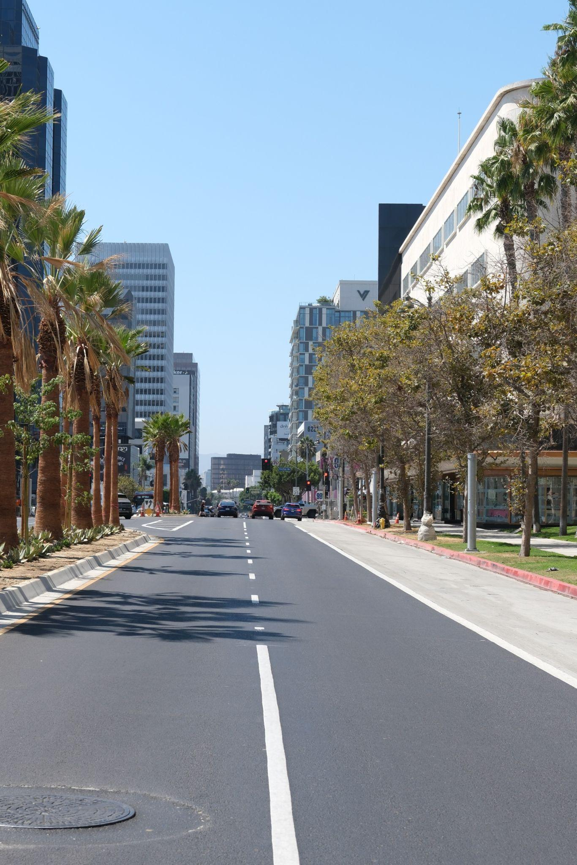
Hello! As you can tell from my website, my name is Derek, and I’m so glad you’re here. I want to take a moment for a deeper introduction since you’ve arrived at my blog. But before I dive into that, let’s talk about the name of my blog.
Why Beyond Good and the Deek? Two simple reasons: I have a knack for cheesy names, and I enjoy philosophy (as you’ll see below). Have I read Beyond Good and Evil? Not yet. But hopefully, I’ll get to it later this year!
A little about me: I graduated from UCI in 2024 with a degree in Computer Science and Engineering. I’m currently navigating the job market (spoiler: it’s tough!). In the meantime, I work at an after-school program, read good books, and dive into fun projects. This website is a product of that; A combination of my portfolio and my blog. This section is my blog, so let’s dive a little deeper.
Here are three things you should know to better understand my blog:
One: I love a good book. Lately, I’ve been immersed in philosophy, reading writers like Kierkegaard, Wittgenstein, and others. Expect a lot of thoughts, questions, and intersections; especially with technology. If that sounds interesting, stick around!
Two: I love adventure, exploration, and a good challenge. This summer, I completed the Rae Lake Loop; a 54-mile hike through the Sierra Nevadas. Occasionally, I’ll share posts about hikes, trips, and other adventures.
Three: I’m endlessly curious. I love exploring, learning, and trying new things. Recently, I’ve been focusing on graphics programming and baking. With graphics programming, I’m working with OpenGL and hope to one day build my own graphics engine. In the kitchen, I’ve been perfecting my focaccia and cinnamon roll recipes.
Finally, I’d love to connect! I’m always open to making new friends and sharing ideas.
I can’t wait to have you join me on this journey :)

